Q1. What is the total amount each customer spent at the restaurant?

QUERY:

SELECT sales.customer_id,

SUM(menu.price) AS total_spend

FROM sales

JOIN menu

ON sales.product_id=menu.product_id

GROUP BY sales.customer_id

ANSWER:

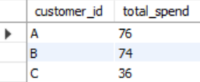

Q2. How many days has each customer visited the restaurant?

QUERY:

SELECT customer_id, count(order_date) AS Total_Visit

FROM sales

GROUP BY customer_id

Answer

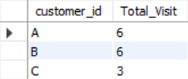

Q3. What was the first item from the menu purchased by each customer?

QUERY:

SELECT customer_id,

product_name,

order_date

FROM (

SELECT s.customer_id,

m.product_name,

s.order_date,

ROW_NUMBER() OVER (PARTITION BY s.customer_id ORDER BY s.order_date) AS rn

FROM sales s

JOIN menu m

ON s.product_id = m.product_id

) t

WHERE rn = 1;

ANSWER

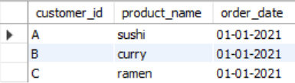

Q4. What is the most purchased item on the menu and how many times was it purchased by all customers?

QUERY

SELECT product_id, COUNT(Product_id) AS Total_purchese

FROM Sales

GROUP BY product_id

ORDER BY Total_purchese DESC

LIMIT 1

ANSWER



Q5. Which item was the most popular for each customer?

QUERY

SELECT customer_id, COUNT(Product_id)

FROM sales

WHERE product_id = 3

Group BY customer_id

SELECT customer_id, product_id, purchase_count

FROM (

    SELECT customer_id,

           product_id,

           COUNT(product_id) AS purchase_count,

           ROW_NUMBER() OVER (

               PARTITION BY customer_id

               ORDER BY COUNT(product_id) DESC

           ) AS rn

    FROM sales

    GROUP BY customer_id, product_id

) t

WHERE rn = 1;

ANSWER

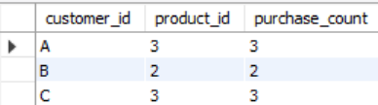

Q6. Which item was purchased first by the customer after they became a member?

QUERY

SELECT customer_id,

product_name,

order_date

FROM (

SELECT s.customer_id,

m.product_name,

s.order_date,

ROW_NUMBER() OVER (

PARTITION BY s.customer_id

ORDER BY s.order_date

) AS rn

FROM sales s

JOIN menu m

ON s.product_id = m.product_id

JOIN members mem

ON s.customer_id = mem.customer_id

WHERE s.order_date >= mem.join_date -- ✅ only sales after membership

) t

WHERE rn = 1;

Answer

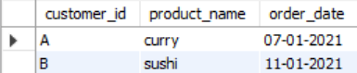

Q7. Which item was purchased just before the customer became a member?

QUERY

SELECT customer_id, product_name, order_date

FROM (

SELECT

s.customer_id,

m.product_name,

s.order_date,

ROW_NUMBER() OVER (

PARTITION BY s.customer_id

ORDER BY s.order_date

) AS rn

FROM sales s

JOIN menu m

ON s.product_id = m.product_id

JOIN members mem

ON s.customer_id = mem.customer_id

WHERE s.order_date < mem.join_date -- before becoming member

) t

WHERE rn = 1;

ANSWER

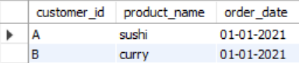

Q8. What is the total items and amount spent for each member before they became a member?

QUERY

SELECT

sales.customer_id,

SUM(menu.price) AS total_spend

FROM sales

JOIN menu

ON sales.product_id = menu.product_id

JOIN members

on sales.customer_id = members.customer_id

WHERE sales.order_date < members.join_date

GROUP BY sales.customer_id

ORDER BY customer_id

ANSWER

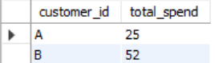

Q9. If each $1 spent equates to 10 points and sushi has a 2x points multiplier - how many points would each customer have?

SELECT

sales.customer_id,

SUM(

CASE

WHEN sales.product_id < 3 THEN menu.price * 10

ELSE menu.price * 20

END

) AS total_spend

FROM sales

JOIN menu

ON sales.product_id = menu.product_id

GROUP BY sales.customer_id;

ANSWER

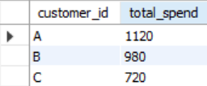

Q10. In the first week after a customer joins the program (including their join date) they earn 2x points on all items, not just sushi - how many points do customer A and B have at the end of January?

QUERY

SELECT

sales.customer_id,

SUM(

CASE

WHEN sales.order_date <= DATE_ADD(members.join_date, INTERVAL 7 DAY)

THEN menu.price * 20

ELSE menu.price * 10

END

) AS Amount_Spend

FROM sales

JOIN menu

ON sales.product_id = menu.product_id

JOIN members

ON sales.customer_id = members.customer_id

GROUP BY sales.customer_id

ORDER BY sales.customer_id;

ANSWER

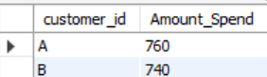

Q11. **Create a detailed dataset that combines customer orders with product details and membership status, and also assigns a ranking to each product purchased after the customer became a member.**

**QUERY**

SELECT sales.customer_id,

sales.product_id,

menu.product_name,

CASE

WHEN members.join_date IS NULL THEN 'N' -- never became a member

WHEN sales.order_date < members.join_date THEN 'N'

ELSE 'Y'

END AS membership,

CASE

WHEN members.join_date IS NULL THEN 'N' -- never became a member

WHEN sales.order_date < members.join_date THEN 'N'

ELSE 'Y'

END AS ranking

FROM sales

JOIN menu

ON sales.product_id = menu.product_id

LEFT JOIN members

ON sales.customer_id = members.customer_id;

ANSWER

